1. V10 http请求重定向到https方法(端口保持 和 端口转发)

【如果想端口保持，则下方的http-redirect标签去除配置 port="6887"即可】

修改配置的方式：

1.Server-config 的network-config下添加

<protocol name="http-redirect">

<http-redirect port="6887" secure="true"></http-redirect>

</protocol>

<protocol name="my-protocol">

<port-unification>

<protocol-finder protocol="http-listener-2" classname="com.apusic.aas.grizzly.config.portunif.HttpProtocolFinder" name="http-finder"></protocol-finder>

<protocol-finder protocol="http-redirect" classname="com.apusic.aas.grizzly.config.portunif.HttpProtocolFinder" name="http-redirect"></protocol-finder>

</port-unification>

</protocol>

2.修改 http-listener-1的协议名为my-protocol

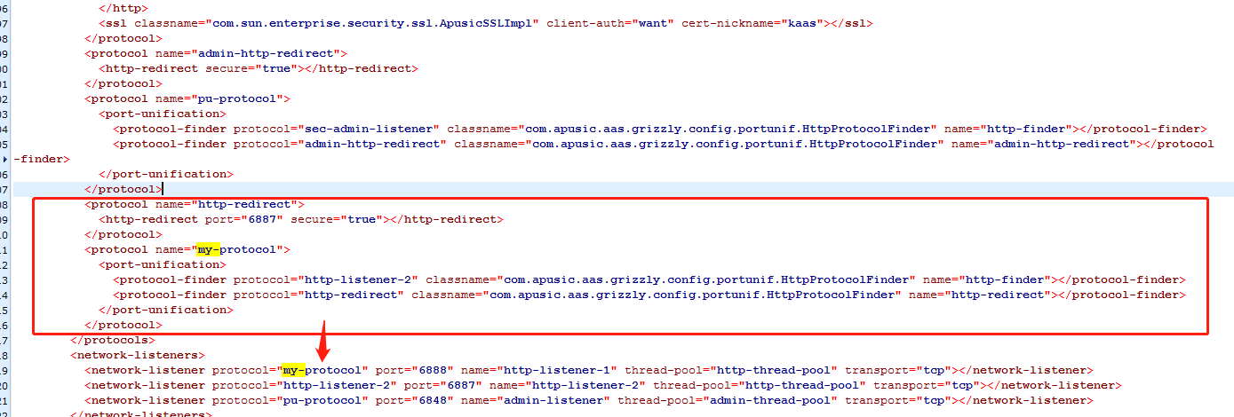

命令行的方式：

1. 在应用的web.xml添加

<security-constraint>

<web-resource-collection>

<web-resource-name>SecureResource</web-resource-name>

<url-pattern>/\*</url-pattern>

</web-resource-collection>

<user-data-constraint>

<transport-guarantee>CONFIDENTIAL</transport-guarantee>

</user-data-constraint>

</security-constraint>

1. 输入以下命令

./asadmin 下执行

1.create-protocol --securityenabled=false http-redirect

2.create-http-redirect --redirect-port 6887 --secure-redirect true http-redirect

3.create-protocol --securityenabled=false my-protocol

4.create-protocol-filter --protocol http-redirect --classname com.apusic.aas.grizzly.config.portunif.HttpRedirectFilter redirect-filter

5.create-protocol-finder --protocol my-protocol --targetprotocol http-listener-2 --classname com.apusic.aas.grizzly.config.portunif.HttpProtocolFinder http-finder

6.create-protocol-finder --protocol my-protocol --targetprotocol http-redirect --classname com.apusic.aas.grizzly.config.portunif.HttpProtocolFinder http-redirect

7.set server-config.network-config.network-listeners.network-listener.http-listener-1.protocol=my-protocol